Lecture 5

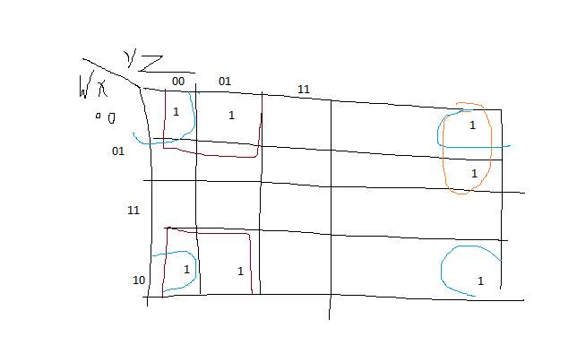

* **Prime Implicant – It’s a product term obtained by combining the maximum possible number of adjacent squares.**
* **Essential Prime Implicant- It occurs when a minterm in a cell is covered by only one prime implicant.**

**Example of prime implicant**

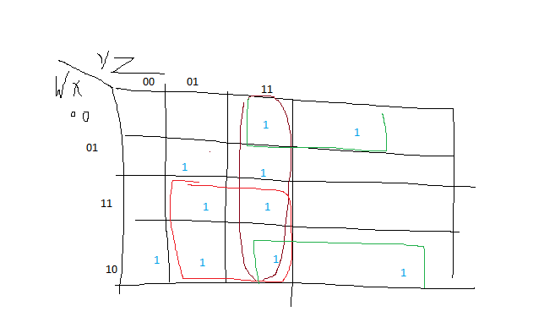

**Essential Prime Implicants Example:-**

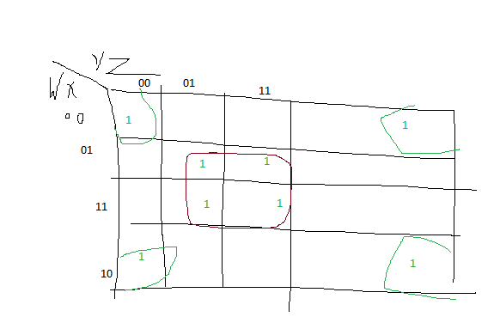

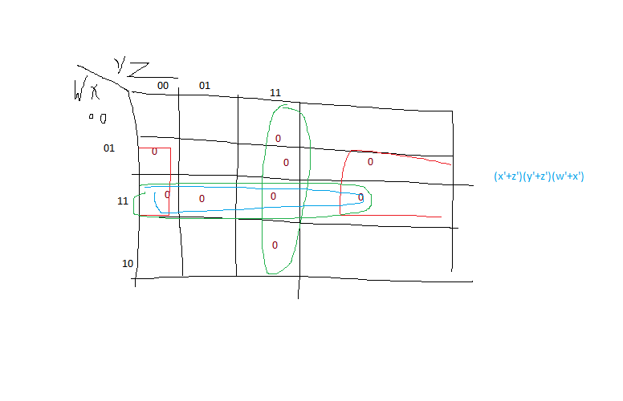

N E S W

0 1 1 1

1 0 1 1

1 1 0 1

1 1 1 0